**DAILY ONLINE ACTIVITIES SUMMARY**

|  |  |  |  |  |  |  |  |
| --- | --- | --- | --- | --- | --- | --- | --- |
| **Date:** | **05-7-2020** | | | | **Name:** | **Harshitha M** | |
| **Sem & Sec** | **8th sem A sec** | | | | **USN:** | **4al16cs038** | |
| **Online Test Summary** | | | | | | | |
| **Subject** | | **No Test** | | | | | |
| **Max. Marks** | |  | | **Score** | |  | |
| **Certification Course Summary** | | | | | | | |
| **Course** | **Introduction to R language tutorial** | | | | | | |
| **Certificate Provider** | | | **Great learning academy** | **Duration** | | | **3.0hr** |
| **Coding Challenges** | | | | | | | |
| **Problem Statement:** **1**. **to read the number and compute the series.**  **2. to count the number in th series.**  **3. to check whether number is palindrome or not.**  **4. to find the number between 0 and 50 which are not divisible by 2 and 3.**  **5.micro and array update**  Top of Form | | | | | | | |
| **Status:completed** | | | | | | | |
| **Uploaded the report in Github** | | | | **yes** | | | |
| **If yes Repository name** | | | | **Harshitha-M** | | | |
| **Uploaded the report in slack** | | | | **yes** | | | |

**Online test**

No Test

**Certification course**

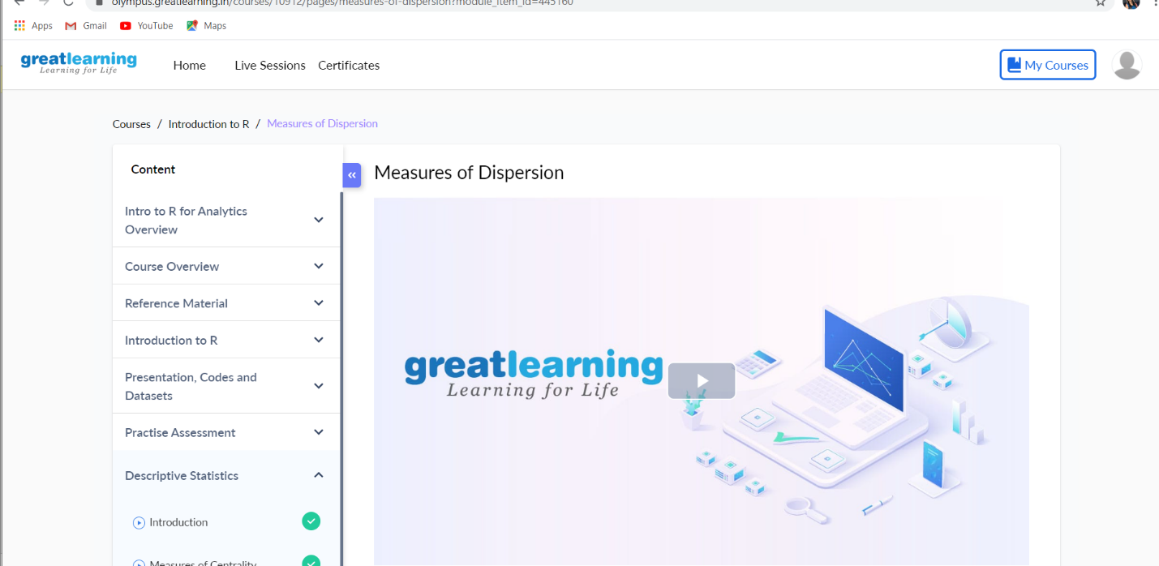

Program 1: No user interaction

/**

* @author: BeginnersBook.com

* @description: Get sum of array elements

*/

class SumOfArray{

public static void main(String args[]){

int[] array = {10, 20, 30, 40, 50, 10};

int sum = 0;

//Advanced for loop

for( int num : array) {

sum = sum+num;

}

System.out.println("Sum of array elements is:"+sum);

}

}

Output:

Sum of array elements is:160